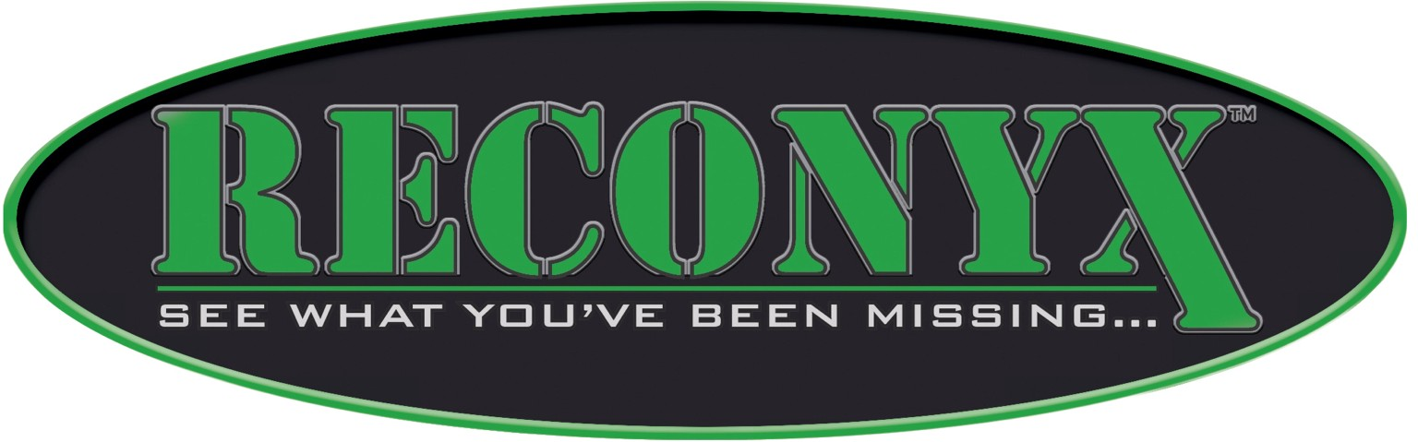

May 9, 2013

RECONYX, Inc.
3828 Creekside Ln
Holmen, WI 54636
608-781-6064

IAC Name: UTC Overseas, Inc.
Date of Notification: 5/9/2013

RE: Consent to Screen Cargo

Under regulations set forth by the Transportation Security Administration (TSA) in the Indirect Air Carrier Standard Security Program (IACSSP) effective Feb 1, 2009:

______________________RECONYX, Inc.__________________________

Hereby authorizes UTC Overseas, Inc. to screen all cargo tendered from the date of this notification forward if required.

Signed,

Daniel A. Luebke
Security Products Manager
RECONYX, Inc.

WARNING: This record contains Sensitive Security Information that is controlled under 49 CFR parts 15 and 1520. No part of this record may be disclosed to persons without a "need to know", as defined in 49 CFR parts 15 and 1520, except with the written permission of the Administrator of the Transportation Security Administration or the Secretary of Transportation. Unauthorized release may result in civil penalty or other action. For U.S. government agencies, public disclosure is governed by 5 U.S.C. 552 and 49 CFR parts 15 and 1520.

